

**WEEK - 4**

**Computer & Networks**

**M. Sumanth Reddy**

**1. create 5 VLANS using switches and configure it with Cisco packet tracer**

**Intro:**

We will build this network using 5 VLAN’s and divide each other into three Blocks.

Block A: - 5 Pc’s

Block B: - 5 Pc’s

Block C: - 5 Pc’s

1 SWITCH is present to connect the three Blocks each other.

**VLAN:** A VLAN is a group of computers which was situated in the same place, and they share the same physical network. Computers on the VLAN connect to same switch by physically or wireless.

**Apparatus:**

In this VLAN Network Project, we had used:

**Switch:** The Switch is used to Connect between two devices and here we have used **2960-24TT** and it consists of 24 ports which means we can connect 24 devices for single Switch which is widely used in Lab, Industrial Purposes.

**Pc:** The Pc is an end device, used as receiver and sender of Packets in this network and by transferring the packets from one Pc to another Pc we can declare working status of the Network.

**Twisted Straight Wire:** Used to Connect the different devices in the Network.

**Construction of the BLOCKS**:

**BLOCK A:** In Block A we have taken 5 Pc’s and giving them IP address as:

PC0: 10.10.10.1 Fastethernet0/1

PC1: 10.10.10.2 FastEthernet0/2

PC2: 10.10.10.3 FastEthernet0/3

PC3: 10.10.10.4 FastEthernet0/4

PC4: 10.10.10.5 FastEthernet0/5

After giving them the IP address now connect the PCs with Switch using Straight forward cable now make sure that all the PCs are connected to the correct Fast Ethernets.

**BLOCK B:** In Block A we have taken 5 Pc’s and giving them IP address as:

PC0: 10.10.10.6 Fastethernet0/6

PC1: 10.10.10.7 FastEthernet0/7

PC2: 10.10.10.8 FastEthernet0/8

PC3: 10.10.10.9 FastEthernet0/9

PC4: 10.10.10.10 FastEthernet0/10

After giving them the IP address now connect the PCs with Switch using Straight forward cable now make sure that all the PCs are connected to the correct Fast Ethernets.

**BLOCK C:** In Block A we have taken 5 Pc’s and giving them IP address as:

PC0: 10.10.10.11 Fastethernet0/11

PC1: 10.10.10.12 FastEthernet0/12

PC2: 10.10.10.13 FastEthernet0/13

PC3: 10.10.10.14 FastEthernet0/14

PC4: 10.10.10.15 FastEthernet0/15

After giving them the IP address now connect the PCs with Switch using Straight forward cable now make sure that all the PCs are connected to the correct Fast Ethernets.

**VLAN Database:**

To apply the VLAN database to the click on the **Switch** and select **config** and open **VLAN database** and there we can see **1** is **Default** and now we must declare 4 more to complete 5 VLANs

Now there are two spaces in the VLAN they are VLAN number and VLAN name now enter:

2 Production

3 Accounts

4 Marketing

5 Distribution

After entering each VLAN we must click the add button it will be added, and we can also remove the VLANs using the remove buttons.

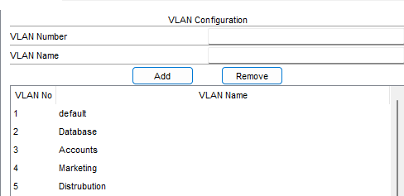

**Configuring the VLANs in the Switch:**

To Configure the VLANs in the Switch:

Open the Switch select the config and click on go to each Fast Ethernet, there is a VLAN column, and we can assign any VLAN configuration for it. As we have known we have 5 VLAN configurations we have given any of them for each PC in every BLOCK.

FAST ETHERNET 0/1: 1

FAST ETHERNET 0/2: 2

FAST ETHERNET 0/3: 3

FAST ETHERNET 0/4: 4

FAST ETHERNET 0/5: 5

FAST ETHERNET 0/6: 1

FAST ETHERNET 0/7: 2

FAST ETHERNET 0/8: 3

FAST ETHERNET 0/9: 4

FAST ETHERNET 0/10: 5

FAST ETHERNET 0/11: 1

FAST ETHERNET 0/12: 2

FAST ETHERNET 0/13: 3

FAST ETHERNET 0/14: 4

FAST ETHERNET 0/15: 5

By declaring this in every PC we can communicate to that specific Pc only...

* This is option to select the VLAN for Fast Ethernet

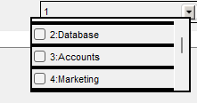

**Procedure:**

After assigning the IP addresses for each Pc and connecting them to Switch we have to configure the 5 VLAN database as Production, Database, Accounts, Marketing and Distribution. Now open the Switch config mode and select the VLAN database and add the 5 VLAN after adding them, now open the Switch click on config and check out the Fast Ethernet, we can see VLAN option where we select 1 to 5 VLANS which was given by us before.

* Now select 1Fast Ethernet with 1VLAN, 2Fast Ethernet with 2, 2Fast Ethernet with 3, 4Fast Ethernet with 4 and 5Fast Ethernet with 5.
* Repeat This process for every Block in the network.

After making sure everything is correct,

* Run the Packets from Same VLAN Pc’s suppose if we want to send the packet from PC1[VLAN2] to PC7[VLAN3] it will raise an error.
* To Overcome this, we must send to only same VLANs as from PC0[VLAN1] to PC5[VLAN1]

Then it will be executed successfully.

**Construction of Network:**

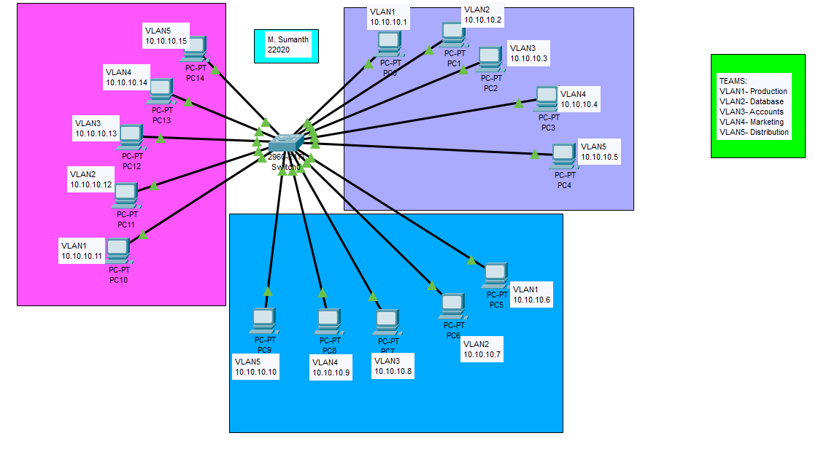

**After Running Packets:**

By transferring the packets, we can know that much about the Network and how it works and there is an any problem any connection and we can rectify it. In below we had assigned the packets for two different Pc’s and the travelling packets, and the switch will send the different packets for every Pc with the unique receiver ID the Pc will respond and it will resend back the packet to the sender, and it will be successful.

**Realtime mode: -**

* RealTime shows the packets that has travelled from one Pc to another Pc is successful or failed.
* If there is a valid connection between the Pc’s it shows Successful or else if connection is interrupted it shows failed.

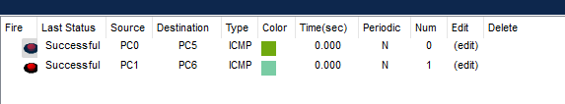

**Simulation mode:**

* If provides the detailed information about the packet from which it travels from one switch to another switch and provides the detailed info about time taken from switch to switch and packet which is at present device.

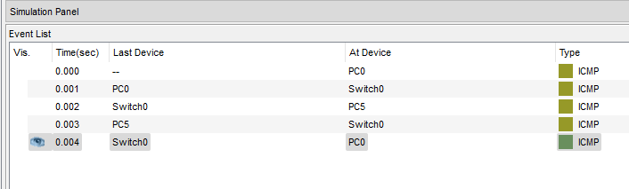

**Failed Case:**

In this case, I have tried to transfer the packet from the VALN1 of Block A to VLAN3 of Block B., Then it will fail due to it will transfer the packets to the same VLANs.

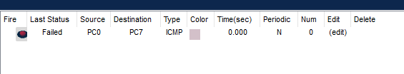

**PING:**

By using Ping, we can check the connection from the one pc to another pc by using IP address and it display the time taken to connect and show no of packets have been transferred, received and lost while transferring.

In Some cases, due to some network issues the packets which was will be lost.

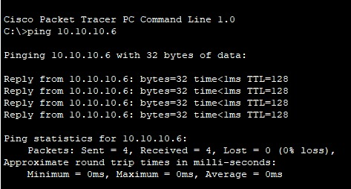

**PROS:**

* **Security:** VLANs provide a level of security by isolating traffic. Devices in one VLAN typically cannot communicate with devices in another VLAN without routing or firewall rules, which helps prevent unauthorized access.
* **Broadcast Control:** VLANs reduce broadcast traffic. In a flat network, broadcast traffic can consume a significant portion of the available bandwidth, causing network congestion. With VLANs, broadcast domains are smaller, and the impact of broadcast traffic is limited to devices within the same VLAN.
* **Traffic Isolation:** VLANs enable you to isolate different types of traffic. For example, you can put voice traffic in one VLAN and data traffic in another, ensuring quality of service (QoS) for critical applications.

**CONS:**

* **Complexity:** Setting up and managing VLANs can be complex, especially in large networks. It requires a good understanding of networking and can be error-prone.
* **Hardware Requirements:** Not all networking equipment supports VLANs. You need VLAN-capable switches and routers to implement VLANs effectively.
* **Performance:** Misconfigurations or improper design can lead to performance issues. Overly complex VLAN setups can cause unnecessary overhead in the network.

**Conclusion:**

In the VLAN we can conclude that we can transfer the packages to a specific PC only it helps in the security and privacy of other PCs and if we try establishing the connection with other PCs it will raise an error.